**Create and print mailing labels for an address list in Excel**

First under A-R-7 (AR Mailing List), create your excel customer list by using the ASCII output option and export and save your file in excel.

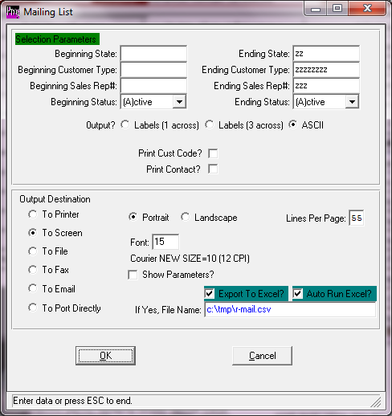

[[Hide All](javascript:AlterAllDivs('none');)Hide All](javascript:AlterAllDivs('none');)

If you want to send a mass mailing to an address list that you maintain in a Microsoft Office Excel [worksheet (worksheet: The primary document that you use in Excel to store and work with data. Also called a spreadsheet. A worksheet consists of cells that are organized into columns and rows; a worksheet is always stored in a workbook.)](javascript:AppendPopup(this,'xldefWorksheet_1_1')), you can use a Microsoft Office Word mail merge. The mail merge process creates a sheet of mailing labels that you can print, and each label on the sheet contains an address from the list.

To create and print the mailing labels, you must first prepare the worksheet data in Excel and then use Word to configure, organize, review, and print the mailing labels.

**Tip**  If Microsoft Office Access is installed on your computer, you can instead export your address list from Excel to Access and then use Access to create and print mailing labels. For more information, see [Exchange (copy, import, export) data between Excel and Access](ms-help://MS.EXCEL.12.1033/EXCEL/content/HA10096300.htm) and [Create mailing labels in Access](ms-help://MS.EXCEL.12.1033/EXCEL/content/HA10007352.htm).

**Step 1: Prepare the worksheet data in Excel for the mail merge**

In Excel, your address list must match the tabular structure that mail merge requires.

1. On a worksheet, do the following to arrange the address list:
   * Use column headers that clearly identify the type of data that each column contains.

**Tip**  For example, use column headers such as **First Name**, **Last Name**, **Address**, and **City** instead of **Column 1**, **Column 2**, **Column 3**, and **Column 4**.

* + Use a separate column for each element that you want to include in the mail merge.

**Tip**  You can also use the mail merge to create form letters that address each recipient by their first name, if you store first and last names in separate columns. You can also add a separate column for a title, such as Mr. or Ms.

* + Include only rows and columns that contain data. Do not include blank rows or columns in the address list, because the list of labels that is created might not be complete beyond the blank rows and columns when you set up the labels for the mail merge in Word.

1. To help locate and select the address list during the mail merge, do the following to define a [name (name: A word or string of characters that represents a cell, range of cells, formula, or constant value. Use easy-to-understand names, such as Products, to refer to hard to understand ranges, such as Sales!C20:C30.)](javascript:AppendPopup(this,'IDH_xldefName_2_2')) for the address list:
   * On the worksheet, select the whole address list, including the cells that contain column headers.
   * On the **Formulas** tab, in the **Defined Names** group, click **Define Name**.

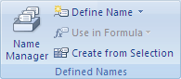

* + In the **Name** box, type a name for the address list, such as **Holiday_Cards**, and then click **OK**.

**Tip**  The first character of a name must be a letter, and you cannot use a space between words. Instead of a space, use an underscore character (_).

1. Save and close the workbook.

**Step 2: Configure the labels for the mail merge in Word**

You configure the layout of the labels just once, for all the labels in the mail merge. In a mail merge, the document that you configure for the layout is referred to as the main document for labels (or label main document). In this document, you can also configure any content that you want repeated on each label, such as a company logo or your return address on shipping labels.

Chances are that you already have a package of label sheets from one of the label sheet suppliers such as Avery, AOne, or Formtec. Each label sheet is a certain size and contains a certain number of labels with specific dimensions.

To configure the label main document, you match its dimensions with the dimensions of the labels on the worksheets that you plan to use.

1. Start Word.

By default, a blank document opens. Leave it open. If you close it, the commands in the next step are not available.

1. On the **Mailings** tab, click **Step by Step Mail merge wizard** and follow steps or On the **Mailings** tab, in the **Start Mail Merge** group, click **Start Mail Merge**.

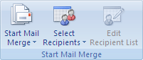

1. Click **Labels**.
2. In the **Label Options** dialog box, you have several choices to make.

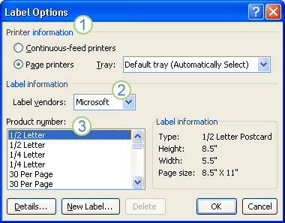

Callout 1The type of printer that you are using to print the labels.

Callout 2The supplier that produced your label sheets.

Callout 3The number that corresponds to the product number listed on your package of label sheets.

[[Show](javascript:ToggleDiv('divExpCollAsst_IDA1GSK'))The product number for my label sheets does not match any one of the choices in the **Label Options** dialog box.](javascript:ToggleDiv('divExpCollAsst_IDA1GSK')%20%20%20%20%20%20%20%20)

You can still print your labels, but you have to do some customizing.

* 1. Measure the labels on the sheet that you are using, and note the measurements and how many labels fit on a single sheet.

**Note**   Measure the labels carefully. The actual label size might be smaller than the size that is indicated by the label manufacturer. For example, a 1-by-2-inch label might actually be 15/16-inch high and 1 15/16-inches wide.

* 1. In the **Product number** list, select a label type that is similar in size to your labels.

If you do not see a substitute label type that you can use in the **Product number** box, you still might be able to use another one of the listed labels. If you don't see a label type that fits your needs, you can create a new label size.

* 1. Click **Details**, and then compare the label dimensions and the number of labels per sheet (for labels printed on laser and ink-jet printers, also referred to as page printers) or the number of columns on the label form (for labels printed on dot-matrix printers, also referred to as continuous-feed printers).
  2. Do one of the following:
     + If the dimensions and label layout match those of your labels, use the selected label.
     + If the dimensions and layout do not match your labels, click **Cancel**.
  3. In the **Label Options** dialog box, click the printer type (either **Continuous-feed printers** or **Page printers**), and then click **New Label**.
  4. Type a name in the **Label name** box, select the height, width, margins, and other options for your label, and then click **OK**.

The new label appears in the **Product number** box as ***Label name* - Custom**. The label is also added to the **Other/Custom** category. The next time that you use your custom labels, make sure that you select **Other/Custom** in the **Label vendors** list.

1. After you select the label options that you want, click **OK**.

Word creates a document that uses a table to lay out the labels. If you do not see lines separating the labels in the layout, click the **Layout** tab under **Table Tools**, and then in the **Table** group, click **View Gridlines**.

**Interrupt and resume a mail merge**

If you need to interrupt your work on a mail merge, you can save the label main document as you would any other document and resume the merge later. Word retains the data source and field information in the document that you save. If you were using the **Mail Merge** task pane when you stopped working on the merge, Word returns to your place in the task pane when you resume the merge.

1. When you are ready to resume the merge, open the label main document that you saved.

Word displays a message box that asks you to confirm that you want to open the document and run an SQL command (the SQL command connects Word to your Excel source file).

1. Click **Yes** to connect to your Excel source file and retrieve your address list.

The text of your label main document, along with any fields that you inserted, appears.

1. Click the **Mailings** tab, and resume your work.

ms-help://MS.EXCEL.12.1033/EXCEL/content/TopPageIcon_CLV.gif [Top of Page](ms-help://MS.EXCEL.12.1033/EXCEL/content/HP10243267.htm#backtotop)

**Step 3: Link the worksheet data to the labels in the mail merge**

To merge the address information into your labels, you must connect the labels to the worksheet that contains your address list.

1. If this is the first time that you have ever connected to a worksheet, do the following:
   1. Click the **Microsoft Office Button** Button image, and then click **Word Options**.
   2. Click **Advanced**.
   3. Scroll to the **General** section, and select the **Confirm file format conversion on open** check box.
   4. Click **OK**.
2. With the mail merge main document open, in the **Start Mail Merge** group on the **Mailings** tab, click **Select Recipients**, and then click **Use Existing List**.



1. Locate the Excel worksheet in the **Select Data Source** dialog box, and double-click it.
2. In the **Confirm Data Source** dialog box, click **MS Excel Worksheets via DDE (*.xls)**, and then click **OK**.

**Note**   If you do not see **MS Excel Worksheets via DDE (*.xls)** in the list, select the **Show all** check box.

1. In the **Microsoft Office Excel** dialog box, for **Named or cell range**, select the cell range or worksheet that contains the information that you want to merge, and then click **OK**.

**Note**   The labels are now connected to the worksheet data, but the sheet of labels is still blank. If needed, you can define the list of recipients as described in step 4, or you can start populating the labels with placeholders for the address information, as described in step 5.

ms-help://MS.EXCEL.12.1033/EXCEL/content/TopPageIcon_CLV.gif [Top of Page](ms-help://MS.EXCEL.12.1033/EXCEL/content/HP10243267.htm#backtotop)

**Step 4: Define the list of recipients that you want to include on the labels**

Word generates a label for each address in your mailing list. If you want to generate labels for only certain addresses in your mailing list, you can choose which addresses (records) to include.

To narrow the list of recipients or to use a subset of the records in your data file, do the following:

1. On the **Mailings** tab, in the **Start Mail Merge** group, click **Edit Recipient List**.



1. In the **Mail Merge Recipients** dialog box, do one of the following:
   * **Select individual records**  This method is most useful if the list is short. Select the check boxes next to the recipients that you want to include, and clear the check boxes next to the recipients that you want to exclude.

**Tip**  If you know that you want to include only a few records in your merge, you can clear the check box in the header row and then select only those records that you want. Similarly, if you want to include most of the list, select the check box in the header row, and then clear the check boxes for the records that you do not want to include.

* + **Sort records**  Click the heading of the column that you want to sort by. Word sorts the list in ascending alphabetical order (from A to Z). Click the column heading again to sort the list in descending alphabetical order (Z to A).

To specify more advanced sorting options, click **Sort** under **Refine recipient list** and select your sorting preferences on the **Sort Records** tab in the **Filter and Sort** dialog box. For example, you can specify that recipient addresses must be alphabetized by last name within each postal code, and that postal codes are listed in numeric order.

* + **Filter records**  This method is useful if the list contains records that you do not want to see or include in the merge. After you filter the list, you can select or clear the check boxes to include or exclude specific records.

To filter records, do the following:

* + 1. Under **Refine recipient list**, click **Filter**.
    2. On the **Filter Records** tab in the **Filter and Sort** dialog box, select the criteria that you want to use to filter your records.

For example, to generate labels only for addresses in Australia, click **Country or Region** in the **Field** list, **Equal to** in the **Comparison** list, and **Australia** in the **Compare to** list.

* + 1. To further refine the filter, click **And** or **Or**, and then select more criteria.

For example, to generate labels only for businesses in Munich, you specify records whose **City** field contains **Munich** and whose **Company Name** field is not blank. If you use **Or** instead of **And** in this filter, your mail merge includes all Munich addresses in addition to all addresses that include a company name, regardless of city.

**Note**   If you have installed address validation software on your computer, you can click **Validate addresses** in the **Mail Merge Recipients** dialog box to validate your recipients' addresses.

ms-help://MS.EXCEL.12.1033/EXCEL/content/TopPageIcon_CLV.gif [Top of Page](ms-help://MS.EXCEL.12.1033/EXCEL/content/HP10243267.htm#backtotop)

**Step 5: Populate the labels with placeholders for address information**

When you perform the mail merge, the mail merge fields are filled with information from your address list.

After you connect your labels to your address list, you are ready to add placeholders that indicate where the addresses will appear on each label. You can also type text that you want repeated on each label, such as a company logo or your return address on a shipping label.

The placeholders for the addresses are called *mail merge fields*. Mail merge fields in Word correspond to the column headers in the data file that you choose.

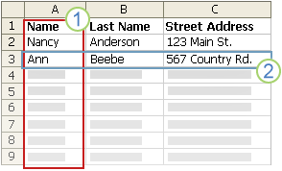

Callout 1Columns in a data file represent categories of information. Mail merge fields that you add to the labels are placeholders for these categories.

Callout 2Rows in a data file represent records of information. Word generates a label for each record when you perform a mail merge.

By putting a mail merge field in the original label that you configured in the label main document, you indicate that you want a certain category of information, such as name or address, to appear in that location.

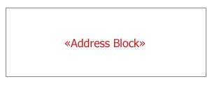

**Note**   When you insert a mail merge field into the label main document, the field name is always surrounded by chevrons (« »). These chevrons do not show up on the final labels — they just help you distinguish the fields in the label main document from the regular text.

**What happens when you merge**

When you perform the mail merge, information from the first row in the data file replaces the fields in the first label. Then, information from the second row in the data file replaces the fields in the second label, and so on.

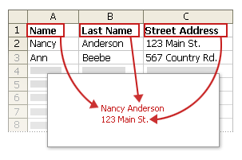

**Working with fields: Examples**

When you design labels, you can link any column heading from your data file to a field in a label.

For example, suppose you have a subscriber list to your newsletter, and your data file includes a column, called ExpireDate, that stores the date that each subscription expires. If you insert an «ExpireDate» field in the label main document before you run the merge, that information is added to each mailing label.

You can combine fields and separate them with punctuation marks. For example, to create an address, you can configure the fields in the label main document as follows:

«First Name» «Last Name»

«Street Address»

«City», «State» «Postal code»

For combinations that you use frequently, like address blocks and greeting lines, Word provides composite fields that group a number of fields together. For example, the Address Block field is a combination of several fields, including first name, last name, street address, city, and postal code.

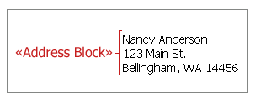

You can customize the content in each of these composite fields. For example, in the address, you may want to select a formal name format (**Mr. Roger Harui**). In the greeting, you might prefer to use "To" instead of "Dear."

**Map the mail merge fields to your data file**

To make sure that Word can find a column in your data file that corresponds to every address element, you might need to map the mail merge fields in Word to the columns in your data file.

To map the fields, click **Match Fields** in the **Write & Insert Fields** group on the **Mailings** tab.

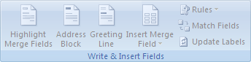

The **Match Fields** dialog box appears.

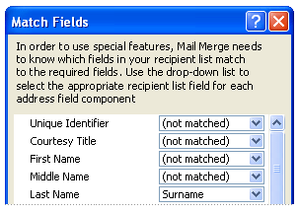

The elements of an address are listed on the left. Column headings from your data file are listed on the right.

Word searches for the column that best matches each element. As the graphic illustrates, Word automatically matched the data file's **Surname** column to **Last Name**, but Word was unable to match other elements, such as **First Name**.

In the list on the right, you can select the column from your data file that matches the element on the left. In the graphic, the **Name** column is now matched with **First Name**. It is okay that **Courtesy Title**, **Unique Identifier**, and **Middle Name** are not matched, because the mail merge label does not need to use every field. If you add a field that does not contain data from your data file, it will appear in the merged document as an empty placeholder — usually a blank line or an empty block of space.

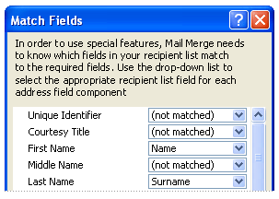

**Type the content and add the fields**

1. In the original label that you configured in the label main document, click where you want to insert the field.
2. Use the **Write & Insert Fields** group on the **Mailings** tab.



1. Add any of the following:

[[Show](javascript:ToggleDiv('divExpCollAsst_IDAP2SK'))Address Block with name, address, and other information](javascript:ToggleDiv('divExpCollAsst_IDAP2SK')%20%20%20%20%20%20%20%20)

* 1. Click **Address Block**.
  2. In the **Insert Address Block** dialog box, select the address elements that you want to include and the formats that you want to apply, and then click **OK**.
  3. If the **Match Fields** dialog box appears, this means that Word is unable to find some of the information that it requires to complete the address block. Click the arrow next to **(not matched)**, and then select the field from your data source that corresponds to the field that is required for the mail merge.

[[Show](javascript:ToggleDiv('divExpCollAsst_IDAK3SK'))Individual fields](javascript:ToggleDiv('divExpCollAsst_IDAK3SK')%20%20%20%20%20%20%20%20)

You can insert information from individual fields, such as first name, telephone number, or the amount of a contribution from a list of donors. To quickly add a field from your data file to the label main document, click the arrow next to **Insert Merge Field**, and then click the field name.

To insert other optional fields in the document, do the following:

* 1. On the **Mailings** tab, in the **Write & Insert Fields** group, click **Insert Merge Field**.
  2. In the **Insert Merge Field** dialog box, do one of the following:
     + To select address fields that will automatically correspond to fields in your data source, even if the names of those fields are not the same as the field names in Word, click **Address Fields**.
     + To select fields that always take data directly from a column in your data file, click **Database Fields**.
  3. In the **Fields** box, click the field that you want.
  4. Click **Insert**, and then click **Close**.
  5. If the **Match Fields** dialog box appears, this means that Word is unable to find some of the information that it requires to insert the field. Click the arrow next to **(not matched)**, and then select the field from your data source that corresponds to the field that is required for the mail merge.

**Note**   If you insert a field from the **Database Fields** list and then later switch to a data source that does not contain a column with the same name, Word will be unable to insert that field information into the merged document.

[[Show](javascript:ToggleDiv('divExpCollAsst_IDAD5SK'))Custom fields from Microsoft Office Outlook contacts](javascript:ToggleDiv('divExpCollAsst_IDAD5SK')%20%20%20%20%20%20%20%20)

To include custom contact fields from Outlook in the label main document, you must start the mail merge from within Outlook. After you start Outlook, you organize the information about your contacts by specifying the fields that you want to use in the merge, and then start the mail merge. After you choose the settings that you want, Word starts automatically and you can complete the merge.

**Configure a view of your contacts that includes custom fields**

* 1. In Outlook Contacts, on the **View** menu, point to **Current View**, and then click **Phone List**.
  2. Right-click a column heading, and then click **Field Chooser**.
  3. In the drop-down list at the top of the **Field Chooser** dialog box, select **User-defined fields in folder**.
  4. Drag the field that you want to add from the dialog box to the column headings. A little red arrow helps you place the field in the location that you want.  
     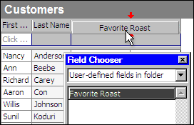

**Note**   You can add a new field in the **Field Chooser** dialog box by clicking **New** at the bottom.

* 1. After you add all of your custom fields to the view, close the **Field Chooser** dialog box.
  2. To remove a field that you do not want included in the mail merge, click the field name in the column heading in Phone List view, and drag it off the column heading.

**Run the mail merge from Outlook**

* 1. In Outlook Contacts, select individual contacts by holding down SHIFT and clicking to select a range, or by holding down CTRL and clicking to select individual contacts. If you want to include all the contacts currently visible in the view, do not click any contacts.
  2. On the **Tools** menu, click **Mail Merge**.
  3. If you selected individual contacts to include in the mail merge, click **Only selected contacts**. If you want to include all the contacts that are currently visible in the view, click **All contacts in current view**.
  4. If you configured the Phone List view so that it displays exactly the fields that you want to use in the mail merge, click **Contact fields in current view**. Otherwise, click **All contact fields** to make all of the contact fields available in the mail merge.
  5. To generate a new main document for the mail merge, click **New document**. Otherwise, click **Existing document**, and then click **Browse** to locate the document to use as the main document.
  6. To save the contacts and fields that you selected so that they can be reused, select the **Permanent file** check box, and then click **Browse**. Outlook saves the data in a Word document (.doc or .docx for Word 2007 or later) as comma-delimited data.
  7. Select **Mailing Labels**.
  8. Click **OK**. After the document opens in Word, on the **Mailings** tab, in the **Write & Insert Fields** group, click the arrow next to **Insert Merge Field**, and then click the fields that you want to add to the label main document.

1. After you finish setting up the first label the way you want it, in the **Write & Insert Fields** group, click **Update Labels**.

Word replicates the layout of the first label to all the other labels.

**Notes**

* You cannot type merge field characters (**«« »»**) manually or use the **Symbol** command on the **Insert** menu in Word. You must use mail merge.
* If the merge fields appear inside braces, such as **{** *MERGEFIELD* City **}**, Word is displaying [field codes (field code: Placeholder text that shows where specified information from your data source will appear; the elements in a field that generate a field's result. The field code includes the field characters, field type, and instructions.)](javascript:AppendPopup(this,'offieldcode_3_3')) instead of [field results (field results: Text or graphics inserted in a document when Microsoft Word carries out a field's instructions. When you print the document or hide field codes, the field results replace the field codes.)](javascript:AppendPopup(this,'wodefFieldResult_4_4')). This doesn't affect the mail merge, but if you want to display the results instead, right-click the field code, and then click **Toggle Field Codes**.

**Format the merged data**

Database and spreadsheet programs, such as Access and Excel, store the information that you type in cells as *raw data*. Formatting, such as fonts and colors, that you apply in Access or Excel is not stored with the raw data. When you merge information from a data file into a Word document, you are merging the raw data without the applied formatting.

To format the data in the document, select the mail merge field and format it, just as you would format any text. Make sure that the selection includes the chevron characters (**« »**) that surround the field.

ms-help://MS.EXCEL.12.1033/EXCEL/content/TopPageIcon_CLV.gif [Top of Page](ms-help://MS.EXCEL.12.1033/EXCEL/content/HP10243267.htm#backtotop)

**Step 6: Preview and print the labels**

After you have added the fields to the original label that you configured in the label main document, you are ready to preview the mail merge results. After you are satisfied with the preview, you complete the mail merge and print the labels. You can then save the label main document for future use.

**Preview the mail merge**

You can preview your labels and make changes before you actually complete the mail merge.

To preview, do any of the following in the **Preview Results** group of the **Mailings** tab:

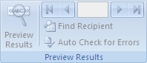

* Click **Preview Results**.
* Page through each label by clicking the **Next Record** and **Previous Record** buttons in the **Preview Results** group on the **Mailings** tab.
* Preview a specific label document by clicking **Find Recipient**.

**Note**   Click **Edit Recipient List** in the **Start Mail Merge** group on the **Mailings** tab to open the **Mail Merge Recipients** dialog box, where you can filter the list or remove recipients from the merge if you see records that you do not want to include.



**Note**   Word uses a table to lay out a sheet of labels on the page. As you page through the labels, the active record is displayed in the first cell of the table, with the following records displayed in subsequent cells.

**Complete the mail merge**

To print the labels, do the following:

1. On the **Mailings** tab, in the **Finish** group, click **Finish & Merge**, and then click **Print Documents**.

Word Ribbon Image

1. Choose whether to print the whole set of labels, only the label that is currently visible, or a specific subset of the labels.

To change individual labels, do the following:

1. On the **Mailings** tab, in the **Finish** group, click **Finish & Merge**, and then click **Edit Individual Documents**.

Word Ribbon Image

1. Choose whether you want to edit the whole set of labels, only the label that is currently visible, or a specific subset of the labels. Word saves the labels that you want to edit to a separate file.

ms-help://MS.EXCEL.12.1033/EXCEL/content/TopPageIcon_CLV.gif [Top of Page](ms-help://MS.EXCEL.12.1033/EXCEL/content/HP10243267.htm#backtotop)

**Step 7: Save the labels for future use**

Remember that the merged labels that you save are separate from the original label that you configured in the label main document. It is a good idea to save the label main document itself if you plan to use it for another mail merge.

When you save the label main document, you also save its connection to the data file. The next time that you open the label main document, Word will prompt you to choose whether or not to merge the information from the data file into the label main document again.

* If you click **Yes**, the document opens with the information from the first record that was merged in.
* If you click **No**, Word breaks the connection between the label main document and the data file, reformats the label main document as a standard Word document, and replaces the fields with the unique information from the first record.